**CSE-5306**

**DISTRIBUTED SYSTEMS**

**PROJECT – 2**

Date: 11/06/2023

**Submitted by:**

**Name**: Mohammad Shahedur Rahman ID: 1002157980

**Name**: Mehzad Hossain Setu ID:1002138330

I have neither given nor received unauthorized assistance on this work.

**Signed:**

Signed: Mohammad Shahedur Rahman Date: 11/06/2023

Signed: Mehzad Hossain Setu Date: 11/06/2023

Table of Contents

Introduction 3

Assignment 1 4

Total Order Multicasting with Lamport’s Algorithm 4

Assignment 2 6

Vector Clock Algorithm 6

Assignment 3 9

Distributed Locking Algorithm 9

Conclusion 10

**Introduction**

The folders contain all the source codes of the programs separated by Assignment name and title. The  
Readme files in each folder contain instructions on how to run the programs for ready reference.

In this programming project, we have practiced programming related to Total Order Multicasting with Lamport’s Algorithm, Vector Clock Algorithm, and Distributed Locking algorithm.

We have used the below-mentioned tools and programming language for this project 2.

1. Oracle VM Box 7.4.10
2. Ubuntu 22.04.3 LTS
3. Python 3.11
4. Other relevant packages.

**Assignment 1**

## **Total Order Multicasting with Lamport’s Algorithm**

In this assignment, we were tasked to implement a Totally Ordered Multicasting system using Lamport’s algorithm. We implemented the algorithm and simulated the output using Python 3.11. The program is implemented in a single file – lamport_clock.py

We employed UDP socket-based communication to facilitate communication between processes. A set number of processes are generated by our primary function (3, this can be easily changed to allow an arbitrary number of processes). We have defined the port numbers as well because, in our scenario, the number of processes is fixed. The Python Multiprocessing module is used to implement each process. The clock and machine operations are carried out by this module. To receive events and communicate with the other processes, a communication thread is also present.

To imitate the operation of a process, we've included a time delay in our software. The process increases its logical clock whenever an event happens and multicasts the event to all other running processes in the network. The other processes increase their logical clocks and add the event to a buffer queue when they receive an event. The message that the communication thread receives determines how it will respond.

* If the received message is an event –

1. It updates its logical clock by comparing its own clock with the timestamp in the received event
2. It puts the event in a priority queue, which is a heap with the event’s timestamp as the comparison key.
3. It broadcasts the acknowledgment for the event at the front of the queue.

* If the received message is an acknowledgment –

1. It increments the acknowledgment count for that event
2. If the event at the front of the queue has received acknowledgments from all other processes, then that event is popped from the heap and processed. Otherwise, it broadcasts the acknowledgment

The sample output of the program runtime is shown below:

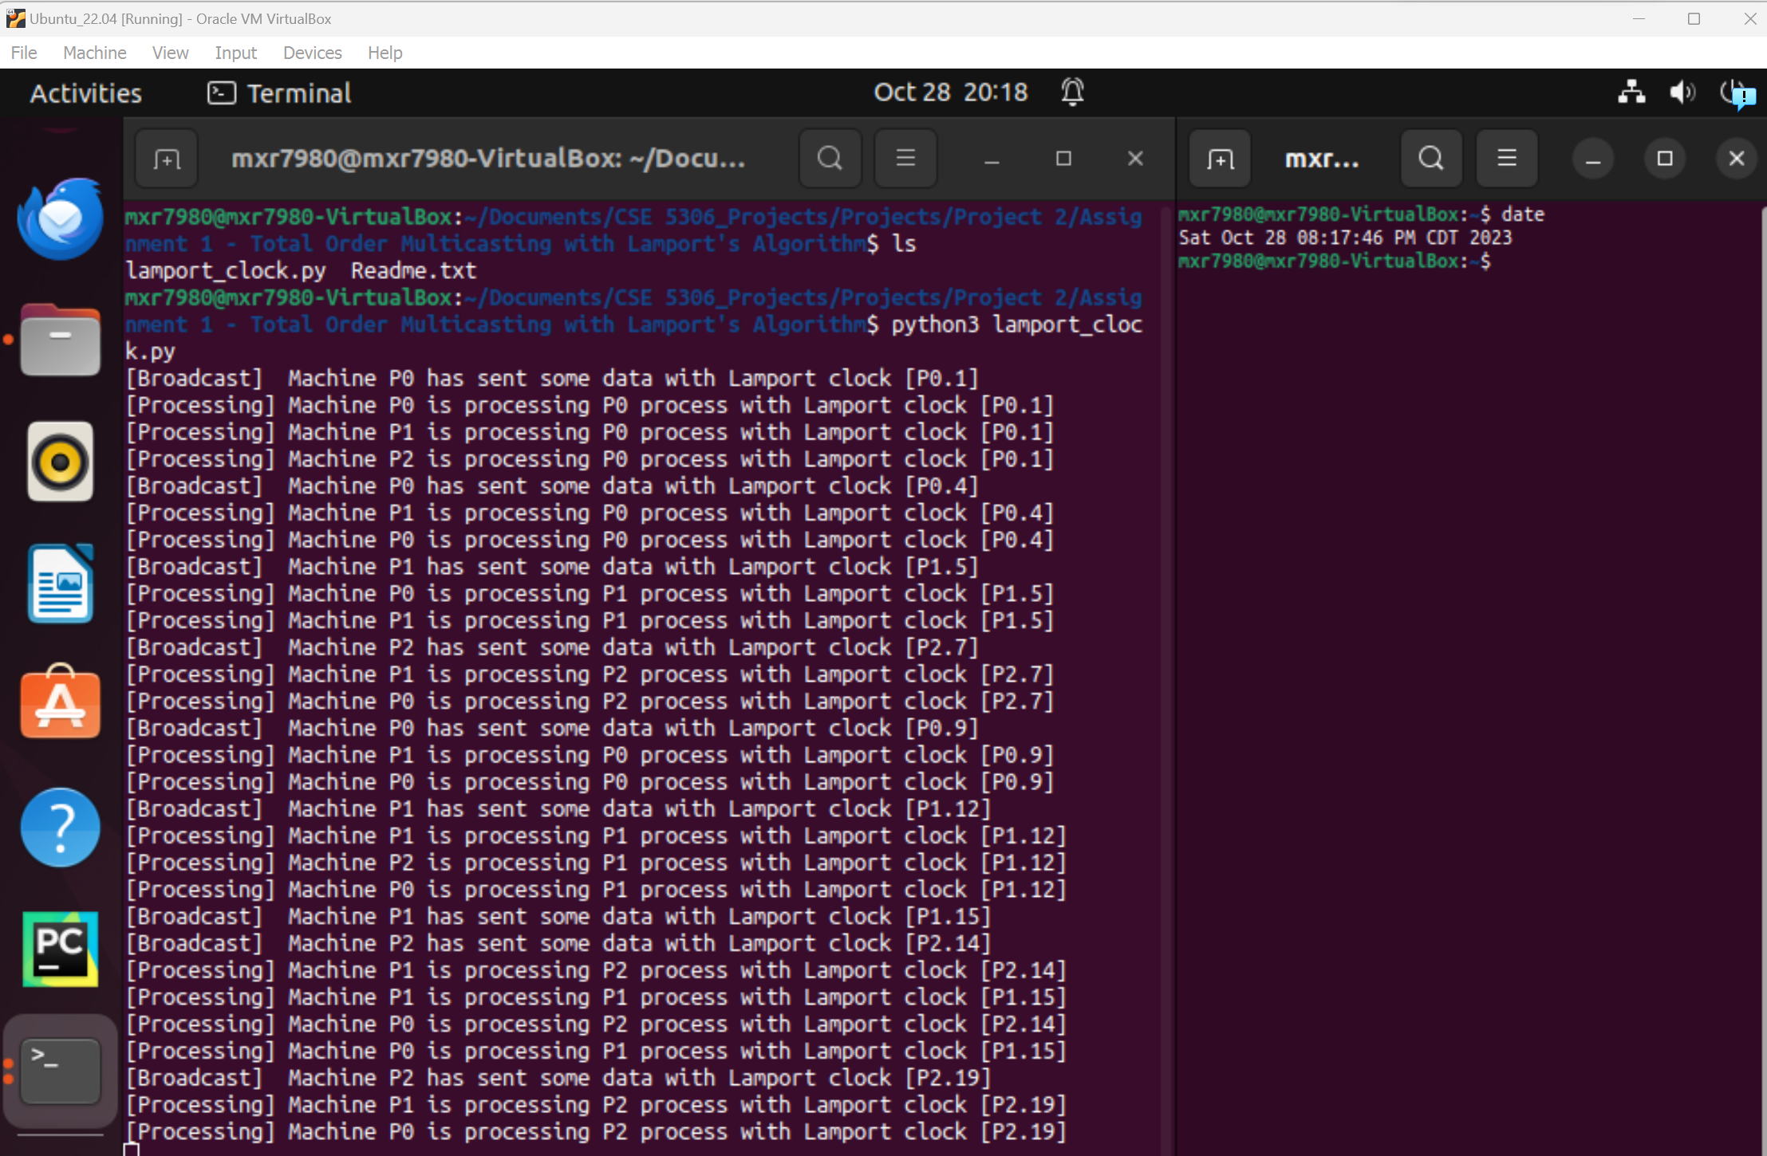

The order in which the machines process the message might change, but the clocks of all the machines are always synchronized to the same value.

**Assignment 2**

## **Vector Clock Algorithm**

In this assignment, we were tasked with implementing the Vector Clock algorithm to enable causally ordered events in a distributed system. We implemented the algorithm and simulated the output using Python 3.11. The program is implemented in separate files:

* server.py
* machine_1.py
* machine_2.py
* machine_3.py

The three machines/processes that will communicate with each other are the files with the names machine_X.py which will communicate with each other through sockets using the server.py. In each process, we created two threads to communicate with each process. One thread is used to send the messages and the other is used to receive.

All clocks are initially set to zero, and before each event, the local clock is increased once. A process provides a copy of its own timestamp when it sends a message so that when a process receives the message, it can increment its own logical clock associated with that machine by comparing its version and the value received from the message and keeping the maximum of the two values. This is repeated for all machines.

In our implementation, before sending a message, we show the vector clock of each machine and increment the clock immediately after sending. The updated vector clock is also displayed in the terminal of each of the processes while the server shows the vector clocks from all the machines.

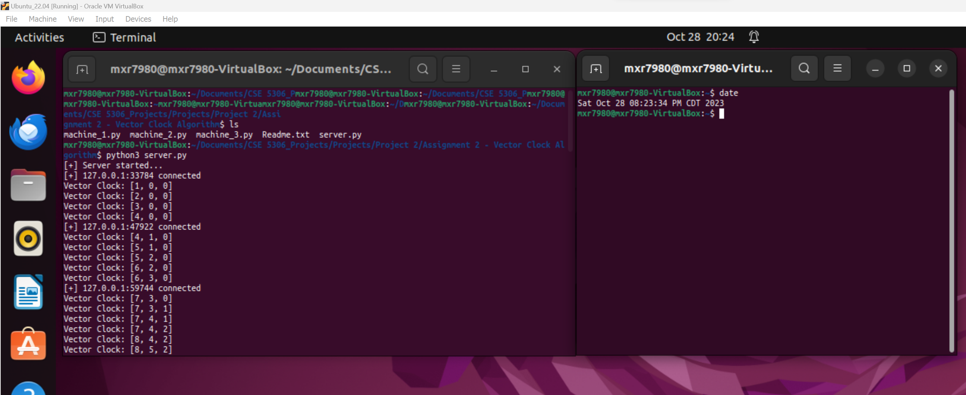

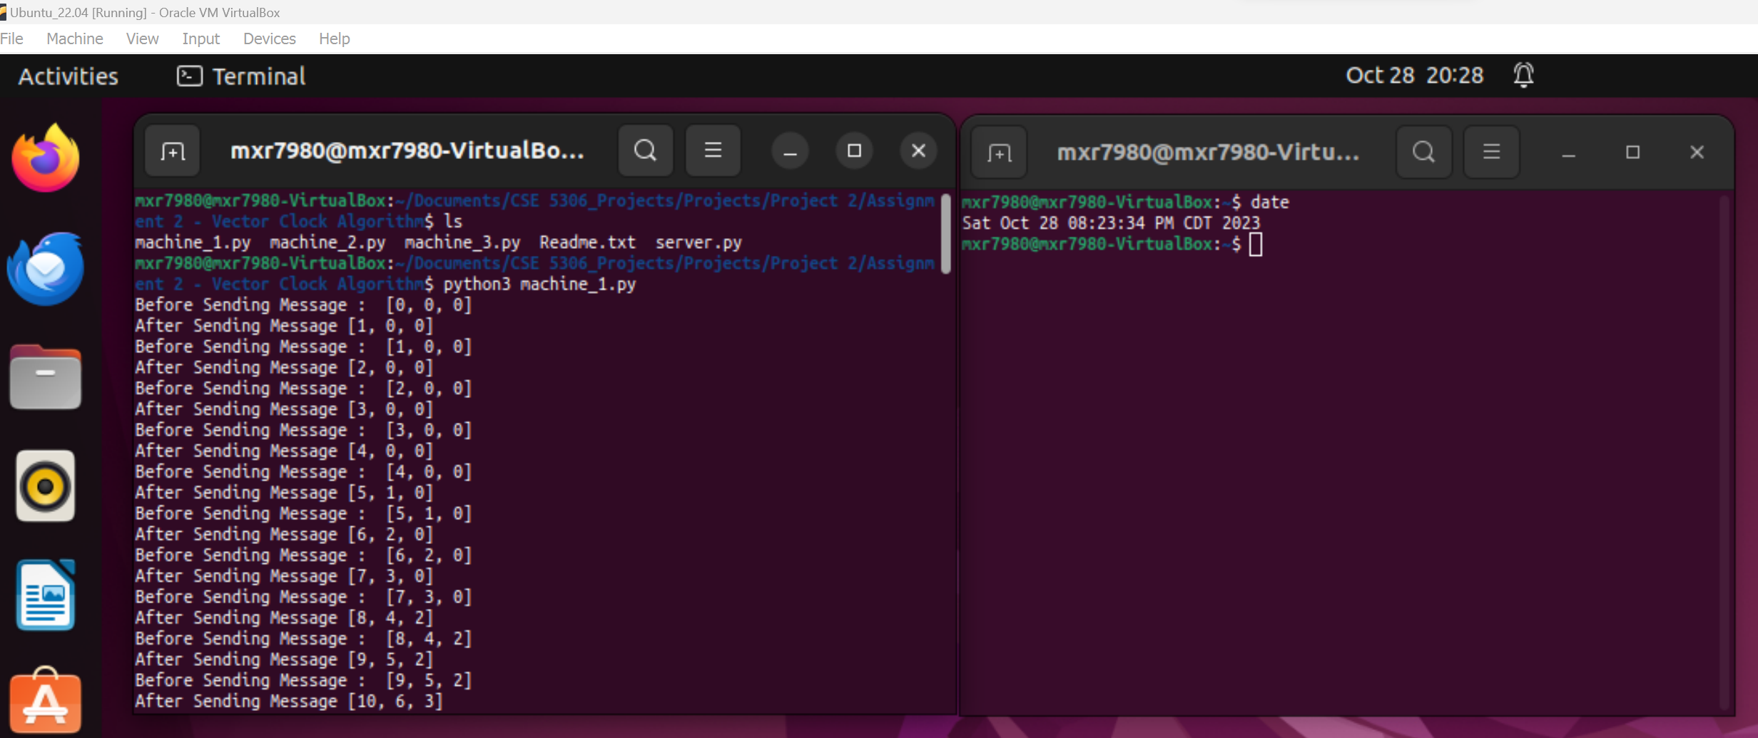

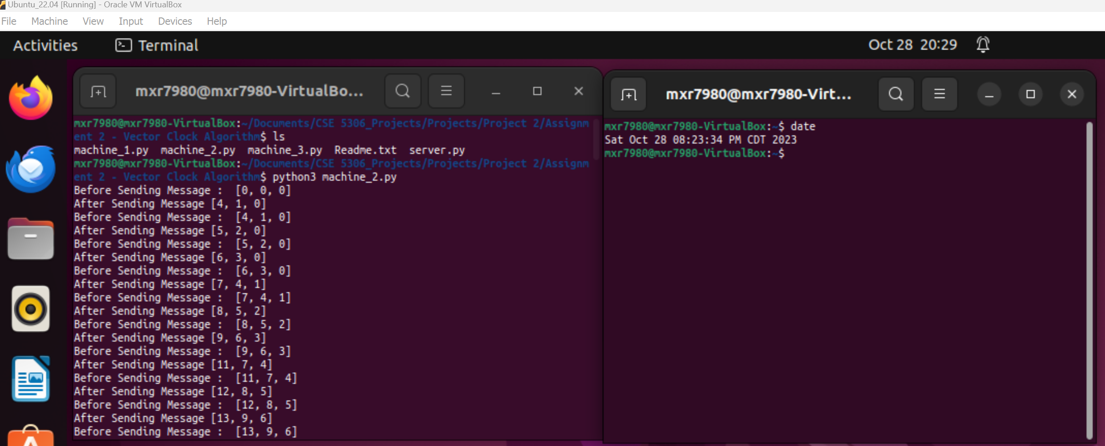

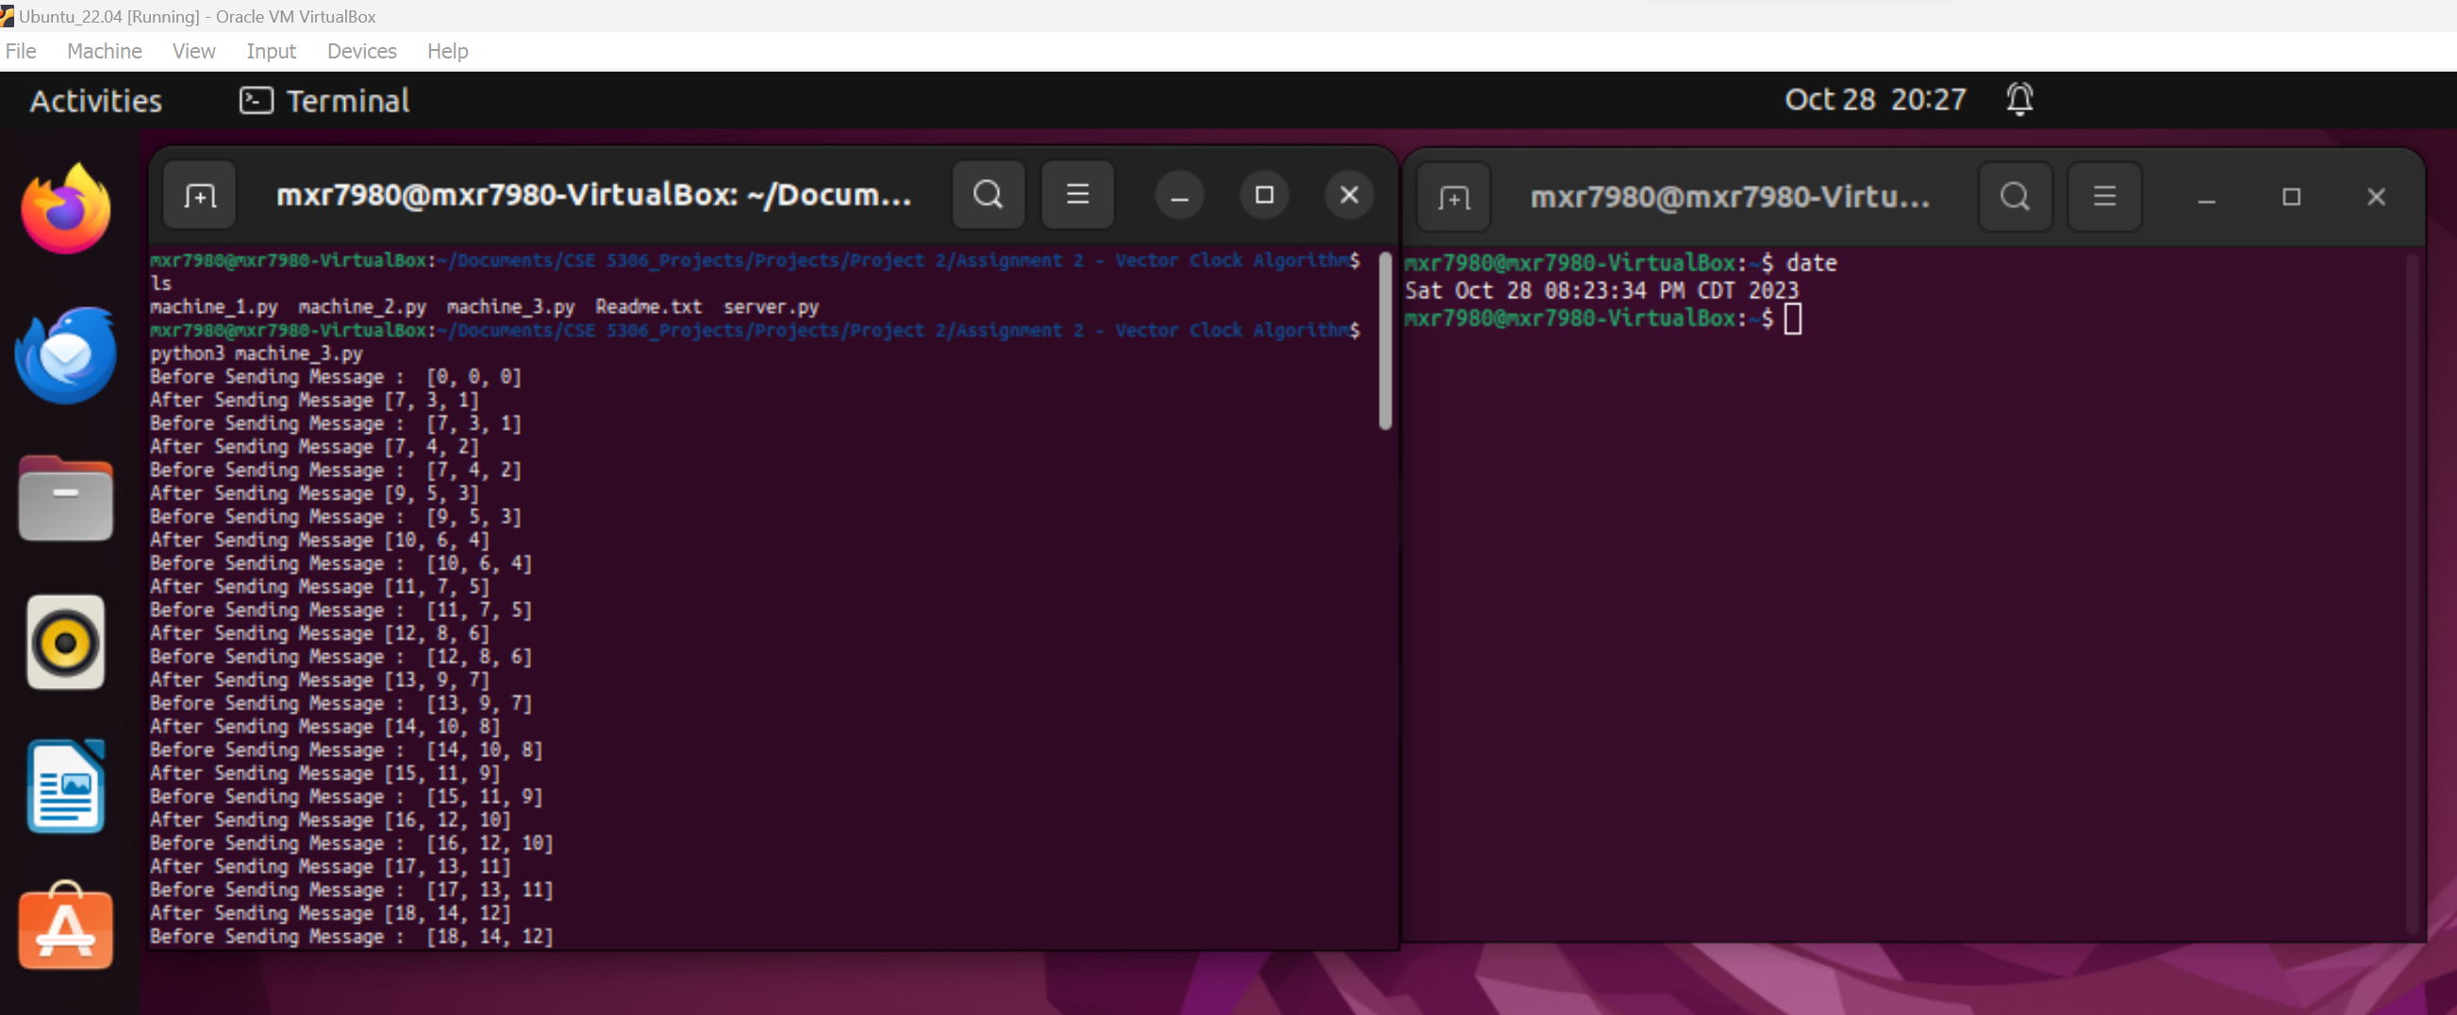

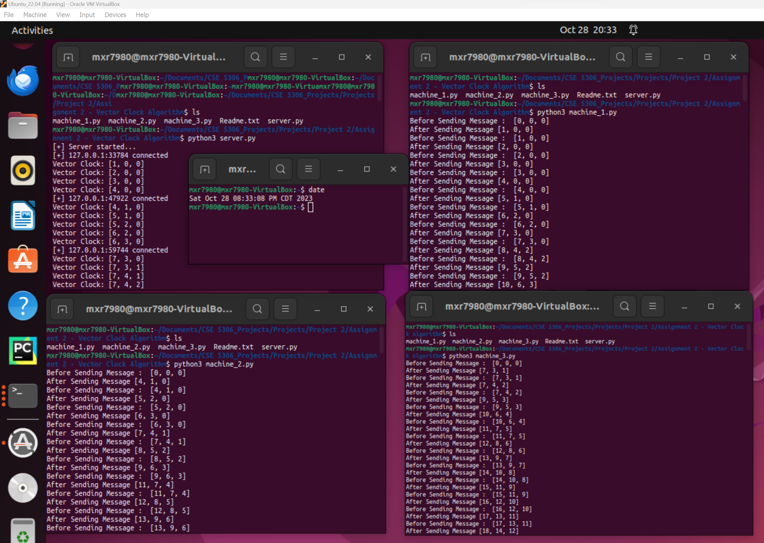

* Vector clock on M1 is on the 1st index [M1, M2, M3]
* When messages from M1 is sent, its counter is increased [1, 0, 0]
* When messages from M2 is sent, its counter is increased [0, 1, 0]
* When messages from M3 is sent, its counter is increased [0, 0, 1]
* When a machine receives a message, it compares its index for that machine and updates its value by keeping the maximum of the two values, for example: M2’s vector clock becomes [1, 1, 0] when it receives the message from M1.
* This pattern can be seen as more messages are sent, but each time the vector clocks are always in order.

**Assignment 3**

## **Distributed Locking Algorithm**

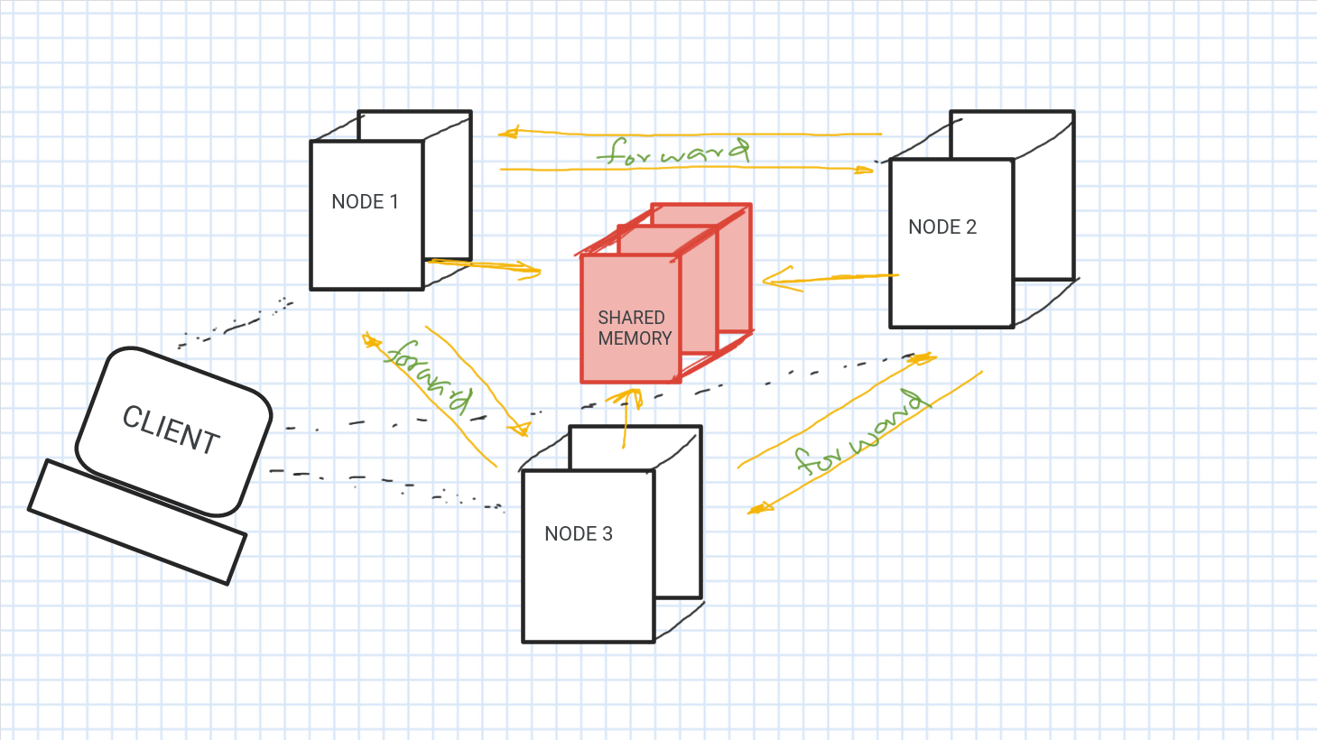

A 3-node distributed system used to lock files saved in shared memory of all the nodes in the distributed system. When a node acquires a lock to a file, the counter is simply updated in the file and then the file gets closed. Using the principles of the token-ring algorithm, we have developed a mechanism to forward the transaction between the nodes in our 3-node distributed system. When a client connects a node to initiate a transaction, the node self-diagnoses its status on whether to process the transaction or to forward the transaction. From the above diagram, we see that the nodes are aligned in circular network topology. When the transaction reaches the node after getting passed over all the other nodes in its network to transact and not get transacted, it checks the transaction and redo the passing, until the transaction is finished. Clients can connect to any node to pass the transaction, but acquiring the lock is automatically managed by the nodes in the distributed system. The system is easily scalable and good to use for the simulation of a locking scheme mechanism. The files are stored in shared memory, which, in our case, is a common directory in a single machine emulating multiple processes as nodes of the distributed system.

During development, I have come across multiple ways of implementing the lock counter handling using configuration files and key-value maps at each node with continuous synchronization and others. Finally, I have concluded and implemented the counter value in the file itself. There are other useful keys similar to the counter-key in each file, such as the status key of the file, whether locked or unlocked, and the name-key of the file for better handling using nodes in our 3-node distributed system.

**Conclusion**

This exercise has explored the basic ideas underlying Total Order Multicasting, Vector Clocks, and Distributed Locking. These algorithms are essential for the development of resilient, dependable, and optimized distributed systems. Total Order Multicasting ensures that all processes in a distributed system receive messages in the same order, regardless of the order in which the messages were sent. Lamport's Algorithm is a simple and efficient way to implement Total Order Multicasting. Vector Clocks provide a way to timestamp events in a distributed system in a way that is consistent across all processes. This is useful for tracking the causal relationships between events, and for detecting and resolving inconsistencies in distributed data. Distributed Locking algorithms allow processes in a distributed system to acquire and release locks on shared resources. This is important for preventing concurrent access to shared resources, which can lead to data corruption and other problems.